29 September, 2014

Team Number: 4 Consultation Day/Hour: Tuesday, 1pm
Team Name: Team 4
Team Members Information:
Group PKB
Saloni Kaur A0084053L a0084053@nus.edu.sg
M I Azima A0085594N a0085594@nus.edu.sg
Group PQL
Saima Mahmood A0084176Y a0084176@nus.edu.sg
Nguyen Trong Son A0088441 A0088441@nus.edu.sg
Vu Phuc Tho A0090585X A0090585@nus.edu.sg
CS3202 Software Engineering Project
Iteration 2 Report

Iteration Overview

Scope of SPA Implemented
In this second iteration we have followed the suggested implementation of the SPA according to the assignment document. We have extended the functionality of the PKB to include the Next relationship. The QP has been extended to deal with multiple clauses. More specifically the Pattern clause has been further implemented to deal with if/else statements and also to deal with more complex expressions.

Achievements & Problems
The main achievement for this iteration would have to be the fact that we managed to complete the requirements that had been left off from iteration 1 and implement all of the functionality required for this iteration. We also spent much more time testing the SPA considering many more test cases.
From iteration one we picked up on some problems of our system. The biggest problem that we picked up on, with the help of our tutor, was with the implementation of the class TNODE. This also affected our Parser. As such we had to spend a considerable amount of time dealing with this problem. This, alongside other issues, will be further elaborated on in section 8.

Project Plans
The way that we have decided to break down the project into tasks is shown in tables 1 and 2 below.

Plan for Whole Project
The breakdown of tasks reflected in table 1 is tentative and will be subjected to change as we move along the various iterations. The subsequent changes, if any, shall be reflected in the reports of the corresponding iteration.
 | Iteration 1 |  |  |  | Iteration 2 |  |  | Iteration 3
Team Member | PKB | Parser | Query Processer | Report | PKB | Query Processer | Report | Affects Relationship | Tuple Results | Report
Azima | * |  |  | * | * |  | * |  |  | *
Saima |  |  | * | * |  | * | * |  |  | *
Saloni | * |  |  | * | * |  | * |  |  | *
Sean |  | * |  | * |  | * | * |  |  | *
Tho |  |  | * |  |  | * | * |  |  | *
Table 1: Whole Project Tasks Breakdown

Plan for Iteration 1
Team Member | Testing | Writing Test Cases | Revamp of TNODE | Next for PKB | Working on QP | Fixing issues with Parser | Report
Azima | * | *
Saima | * | * |  |  | * |  | *
Saloni | * | * |  | *
Sean | * |  |  |  |  | *
Tho | * |  | * |  | * |  | *
Table 2: Iteration 1 Work Distribution

UML Diagrams
The UML sequence diagrams presented in this section display how the SPA program flow works between the Parser, PKB and QP. These diagrams allowed us to visualize the various component interaction of the SPA and thus aided in the project planning.

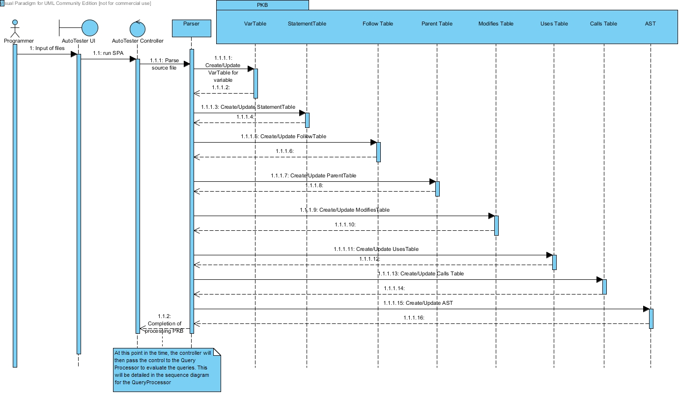
Figure 1: Sequence Diagram for Processing PKB
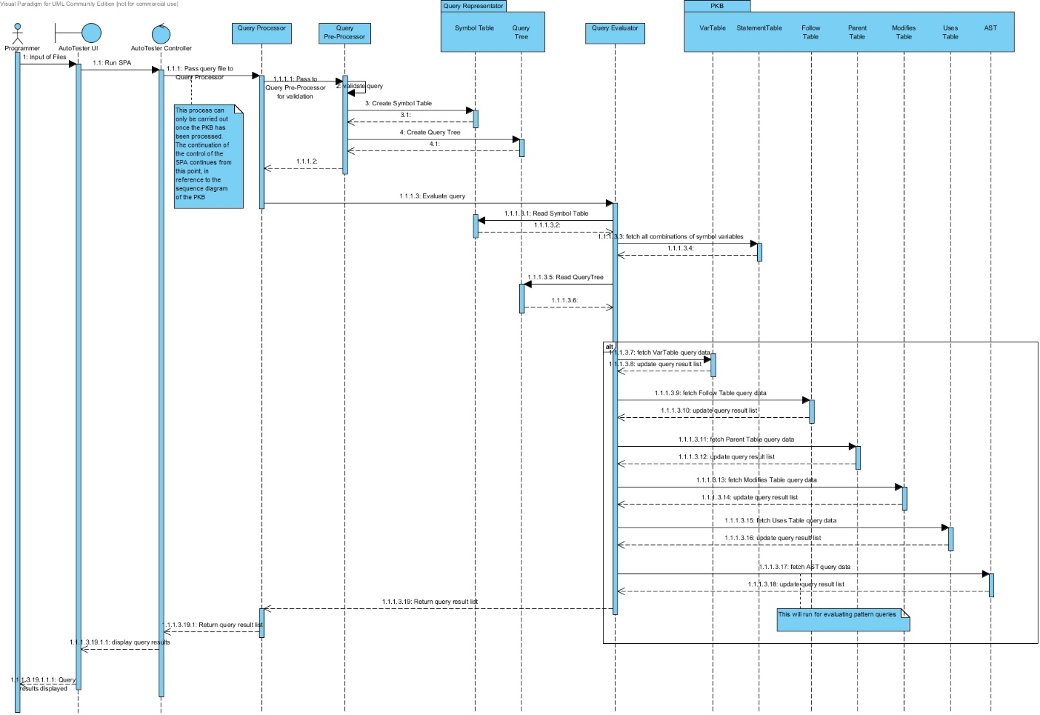
Figure 2: Sequence Diagram for Query Processor Flow

Design Decisions
In Iteration 1 our team has revamped the internal structure of the PKB to allow access to the various tables, in the PKB, with a smaller time complexity. Our previous approach was using a vector of integer pairs to store the relationships such as Follows, Modifies, Uses and Parent. An example of how the Follow table was previously represented is shown in Fig. 1.
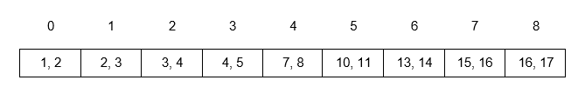
Figure 3: Previous Representation of Follow Table
The vector holds elements which are pairs of statement numbers that obey the Follow relationship. For example, in index 3, statement number 4 is followed by statement number 5. This way, methods such as getFollowingStmt(4) would return the second element of each element which stores a first element of 4. In this example the time complexity of retrieving the element would been O(n).
In our revised version of the PKB, we have decided to change the internal structure of all the relationship storage to 2D vectors storing Boolean values. This way the time complexity is now O(1)to retrieve an element from the table. Fig. 2 shows the representation of the Follow table after the change of the data structure.
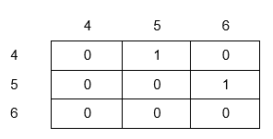
Figure 4: Updated Representation of Follow Table
The vertical and horizontal indexes refer to statement numbers. For example, in this case getFollowingStmt(4) returns the statement numbers which have a TRUE (1) in the horizontal row of index 4. It is statement number 6 in this case.
As a result of the abstract class of PKB, any internal changes made to the PKB do not affect the other components such as the Query Evaluator or the Parser, even though they interact with the PKB. This is a reflection of good separation of concerns and object oriented design of our program.
In addition to the changes made to the PKB, we have updated how we deal with returning vectors. To further improve the system, we have also ensured that we only return a reference to a vector, instead of returning a vector of integers itself, as we did in the previous version of the SPA. As the method receiving the vector of integers does not modify the vector, it is more efficient to return a reference. As such, the speed of the program is also improved.
(talk abt the design decision of next/next*)
(talk abt revamping the design of tnode)

Coding Standards & Experiences
In terms of the coding standards, our group has decided to adopt the following naming conventions described in this section.

Naming Conventions

General Rules
- Do not use underscore, hyphen or any other non-alphabet characters.
- Any name should has all the first letters of internal words capitalized, e.g. getProcName()
- Avoid using abbreviations. Some words are acceptable in short forms, including: Var, Proc, Stmt, AST. Other words such as Children, Number should be fully spelled out.

Specific Rules
- API Name:
- API names should be nouns, in mixed case with the first letter of each internal word capitalized.
- Method:

- Method names should be in the form of a verb. With method names containing more than one word, use mixed case with the first letter of each internal word capitalized.

- Name of some specific methods:
- Methods to insert new records to the database should have the form insertXXX().
- Methods with return value type BOOLEAN should have the form: isXXX() e.g. isExist(), isMatchVar().
- Methods with return types of other values should have the form getXXX() e.g. getVarName()
- Methods that return the number of records inside a table/ list should have the form getSize().
- Methods that change the values or status of an object should have the form: setXXX()
- Methods that return values from star queries, such as Calls* and Next*, should have the form getXXXStar().
In all of the above examples, the “XXX” is used in place of the specific name that the method will adopt.

To keep the abstract and concrete PKB API in sync, we created a variable table, statement table and procedure tables. These tables are vectors mapping variable names to indexes of the vectors. So that a API method like BOOLEAN isModifies(STMT_NUM s1, INDEX varIndex)understands that INDEX is the mapped value of a certain variable name, where INDEX is just an integer in C++ type.

Query Processing

Query Validation
REDO THIS SECTION
The query validating process is handled by the QueryPreprocessor (QPP). The QPP will read and validate data from the query file, and store all necessary information for query evaluation in the Query Representator (QR).
During validation, the QPP checks each query line by line, following these rules:
- On finding a line containing a declaration (e.g. stmt s;), QPP will send this part to the checkDeclaration() method.
- On finding a line containing a query part (e.g. Select s such that Follows(s, 1)), QPP will send this part to checkQueryPart() method.
- While the checkQueryPart() method runs, if the QPP finds a new clause of query, it will call the corresponding method checkClause() (e.g. checkSuchThatCondtion() ) for this clause. Currently, we have provided the methods for “such that” clause and “pattern” clause.
After validating the query, if no error is found, the QPP will save validated data in the QR.

Query Evaluation
REDO THIS SECTION
The query evaluation process is carried out by the QE. Using the stored data from the QR and PKB, the QE will try to find values that satisfy the query’s conditions, and send the list of result values to the AutoTester.
During the evaluation of a query, firstly, the QE will create a list of values for all parameters declared in that query. After that, it will check all of the query’s conditions one by one, attempting to update the list with values of parameters that satisfy the conditions. If it meets any condition that no value can satisfy, the QE will hang up the process and return an empty list as the result of the query.
After the process finishes, with all conditions being satisfied, the QE will take the result value and save it to the result list. This is the list that will be output to the user.

Testing

Test Plan
In this iteration we continuously tested each and every component after changes were made. We made the decision that unit testing on each component would be done by the person implementing the component. Integration testing amongst components would be carried out by the people responsible for the specific components. Finally validation testing will be carried out by everyone at various points of progress during development.
In some aspects of the testing we have used assertions. Examples of where they were used will be shown in the figures shown below in the following sub-sections.

Examples of Test Cases

Unit Testing

PKB
Sample 1
Test Purpose: To test the Parent Table
Required Test Inputs: Parent table and CPP Unit test case for Parent Table. An example is shown in figure 5 below.
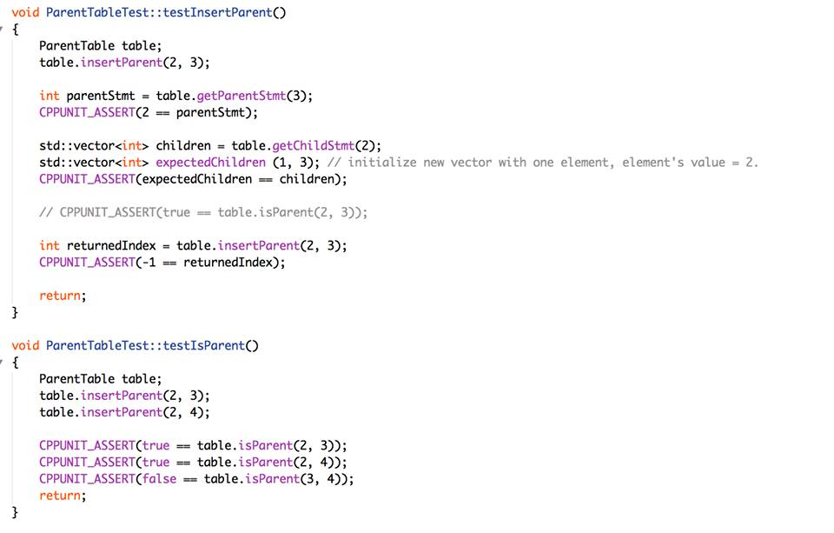
Figure 5: Parent Table Unit Test
Expected Test Results: “OK” This uses the CPP Unit assert, as seen in figure 5 above.
Other Requirements: None

Sample 2
Test Purpose: Uses Table
Required Test Inputs: Use Table and and CPP Unit test case for Uses Table. An example is shown in figure 6 below.

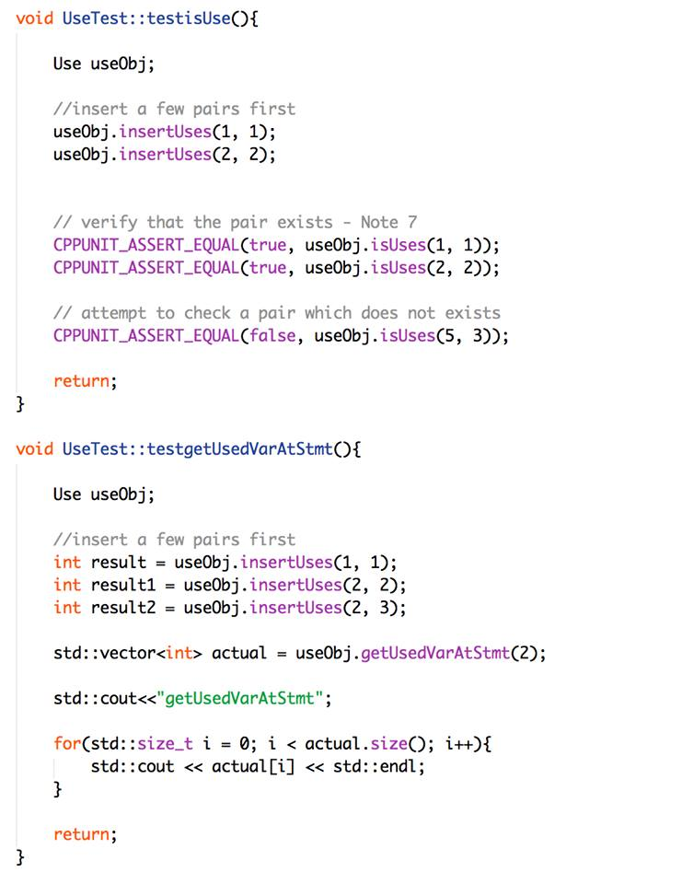
Figure 6: Uses Table Unit Test

Expected Test Results: “OK” This uses the CPP Unit assert, as seen in figure 6 above.
Other Requirements: None

Parser
Test Purpose: To test the Parser component of the SPA
Required Test Inputs: Parser and CPP Unit test case for Parser. An example is shown in figure 7 below.

Figure 7: Excerpt f Parser Test File

Expected Test Results: As seen in figure 8. This uses the CPP Unit assert, as seen in figure 7 above.
Figure 8: Test Results for Unit Testing

Other Requirements: None

Integration Testing

Parser & PKB
Figures 5- 7 show the implementation of the integration testing done using CPP Unit.
Test Purpose: To test the correctness of the interaction between the Parser and PKB.
Required Test Inputs: Parser and PKB.
Expected Test Results: Passed all
Other Requirements: None

Figure 9: CPP Unit Integration Testing for Parser & PKB
Figure 10: CPP Unit Integration Testing for Parser & PKB

PKB & QP
Test Purpose: To test the correctness of the interaction between the PKB and QP.
Required Test Inputs: PKB and QP
Expected Test Results: Passed all.
Other Requirements: None

Figure 11: CPP Unit Integration Testing for PKB & QP

Validation Testing
Sample 1
Test Purpose: To test the program's ability to parse multiple nested while loops and a variety of variable names.
Required Test Inputs: The whole system. Source file and query file.
procedure proc234 {  rose = 3 + r;  while rose  {  o = 6;  s = o + e;  while s {  e = 2 + o + s + e;  }  e = 8;  lily = r + e + rose;  while r {  while o {  while s {  tulip = rose + lily + 4;  }  }  flower = tulip + lily;  flower = flower + rose;  }  flower = 3;  r = flower + 123;  o = r + o + s + e;  }  x = 3;  carnation = yellow + lily;  yellow = 8 + carnation + 6 + yellow;  while o {  l = l + i + l + y;  lavender = lily + 8 + a + e;  e = lavender + 2 + l;  }  r = r + e + 2 + e + d;  while e {  w = 2;  }  } | \\1  \\2  \\3  \\4  \\5  \\6  \\7  \\8  \\9  \\10  \\11  \\12  \\13  \\14  \\15  \\16  \\17  \\18  \\19  \\20  \\21  \\22  \\23  \\24  \\25  \\26  \\27
Figure 12: Sample Source File
Expected Test Results: As shown in figure 9 below.
Queries and Expected Output
35
cat: All Category
1 - Follows, ImplStmtLine ::
stmt s1;
Select s1 such that Follows(s1, 4)
3
5000
2 - Follows, ImplStmtLine ::
stmt s2;
Select s2 such that Follows(7, s2)
8
5000
3 - Follows, ImplStmtLine ::
stmt s;
Select s such that Follows(12, 13)
5000
4 - Follows Star, ImplStmtLine ::
stmt s2;
Select s2 such that Follows*(3, s2)
4, 5, 7, 8, 9, 15, 16, 17
5000
5 - Follows Star, ImplStmtLine ::
stmt s1;
Select s1 such that Follows*(s1, 25)
1, 2, 18, 19, 20, 21
5000
6 - Follows Star, ImplStmtLine ::
constant c;
Select c such that Follows*(19, 21)
3, 6, 2, 4, 123, 8
5000
7 - Parent, ImplStmtLine ::
while w;
Select w such that Parent(w, 19)
5000
8 - Parent, ImplStmtLine ::
stmt s;
Select s such that Parent(21, s)
22, 23, 24
5000
9 - Parent, ImplStmtLine ::
stmt s;
Select s such that Parent(25, s)
5000
10 - Parent Star, ImplStmtLine ::
while w;
Select w such that Parent*(w, 12)
11, 10, 9, 2
5000
11 - Parent Star, ImplStmtLine ::
stmt s;
Select s such that Parent*(2, s)
3, 4, 5, 6, 7, 8, 9, 10, 11, 12, 13, 14, 15, 16, 17
5000
12 - Parent Star, ImplStmtLine ::
while w;
Select w such that Parent*(5, 6)
2, 5, 9, 10, 11, 21, 26
5000
13 - Modifies, ImplStmtLine ::
assign a;
Select a such that Modifies(a, "flower")
13, 14, 15
5000
14 - Modifies, ImplStmtLine ::
variable var;
Select var such that Modifies(24, var)
e
5000
15 - Modifies, ImplStmtLine ::
stmt s;
Select s such that Modifies(s, "e")
2, 5, 6, 7, 21, 24
5000
16 - Uses, ImplStmtLine ::
variable v;
Select v such that Uses(17, v)
r, o, s, e
5000
17 - Uses, ImplStmtLine ::
stmt s;
Select s such that Uses(s, "e")
2, 4, 5, 6, 8, 17, 21, 23, 25, 26
5000
18 - Uses, ImplStmtLine ::
assign a;
Select a such that Uses(16, "flower")
1, 3, 4, 6, 7, 8, 12, 13, 14, 15, 16, 17, 18, 19, 20, 22, 23, 24, 25, 27
5000
19 - Parent, ImplStmtLine ::
while w1; while w2;
Select w1 such that Parent(w1, w2)
2, 9, 10
5000
20 - Parent, ImplStmtLine ::
stmt s;
Select s such that Parent(s, 1)
5000
21 - Parent Star, ImplStmtLine ::
while w;
Select w such that Parent*(9, w)
10, 11
5000
22 - Pattern, Typed ::
assign a; variable v;
Select a pattern a(v, _"o+s"_)
5000
23 - Pattern, Typed ::
assign a;
Select a pattern a(_, _"r + e"_)
8, 25
5000
24 - Pattern, Typed ::
assign a;
Select a pattern a(_, _" yellow + lily"_)
19
5000
25 - Pattern, Modifies ::
assign a;
Select a such that Modifies(a, "flower") pattern a(_, _" tulip + lily"_)
13
5000
26 - Pattern, Uses ::
assign a;
Select a such that Uses(a, "a") pattern a(_, _"lily + 8"_)
23
5000
27 - Modifies, Pattern ::
assign a; while w; variable v;
Select a such that Modifies(w, v) pattern a(v, _"r + e"_)
8, 25
5000
28 - Typed, Pattern, Uses ::
assign a; variable v;
Select v pattern a(v, _) such that Uses(a, v)
e, flower, o, yellow, l, r
5000
29 - Typed, Pattern, Modifies ::
assign a; while w; variable v;
Select w pattern a(v, _"rose + lily"_) such that Modifies(w, v)
2, 9, 10, 11
5000
30 - Typed, Pattern, Modifies ::
assign a; variable v;
Select a pattern a(v, _) such that Uses(a, "lily")
12, 13, 19, 23
5000
31 - Typed, Pattern, Parent ::
assign a; while w;
Select a pattern a(_, _"flower"_) such that Parent(w, a)
14, 16
5000
32 - Typed, Pattern, Follow ::
assign a; while w;
Select a pattern a(_, _"8 + carnation"_) such that Follows(a, w)
20
5000
33 - Typed, Pattern, FollowStar ::
assign a;
Select a pattern a(_, _"e"_) such that Follows*(3, a)
4, 8, 17
5000
34 - Typed, Pattern, ParentStar ::
assign a;
Select a pattern a(_, _"rose+lily"_) such that Parent*(2, a)
12
5000

Figure 13: Expected Test Results

Other Requirements: None
Sample 2
Test Purpose: To test the program's ability to parse multiple nested while loops, irregular spacing between statements and variables and factors. It also includes a large number of variable names.
Required Test Inputs: Whole system. Source file and query file.
procedure spacersoul{
i = 5; \\1
while i{ \\2
j = j + k; \\3
while h{ \\4
while s \\5
{
f = 34; \\6
x = x + h + t + m + l; \\7
}
while f{ \\8
m = 3; \\9
while da{ \\10
plain = boring; \\11
while boring{ \12
a = a + 42; \\13
while q \\14
{
q = q + m + h + k+ 7; \\15
while e{ \\16
summer = summer + holiday + internship + sg; \\17
while internship{ \\18
buggy = small; \\19
buggy = big; \\20
while big \\21
{
headache = headache + 1000 + a + b + c + d + e + f + g + h; \\22
meow = meow + meow + pat + pat +32; \\23
while term \\24
{
41
busy = busy + hah + deadline + 5; \\25
}
}
}
}
}
}
}
}
a = 2; \\26
}
}
}

Figure 14: Sample Source File
Expected Test Results: As shown in in figure 11 below.

Queries and Expected Output
18
cat: All Category
1 - Follows, ImplStmtLine ::
stmt s1;
Select s1 such that Follows(s1, 12)
11
5000
2 - Follows, ImplStmtLine ::
stmt s2;
Select s2 such that Follows(11, s2)
12
5000
3 - Follows, ImplStmtLine ::
stmt s;
Select s such that Follows(12, 13)
5000
4 - Follows Star, ImplStmtLine ::
stmt s2;
Select s2 such that Follows*(5, s2)
8, 26
5000
5 - Follows Star, ImplStmtLine ::
stmt s1;
Select s1 such that Follows*(s1, 24)
22, 23
5000
6 - Follows Star, ImplStmtLine ::
constant c;
Select c such that Follow*(19, 21)
2, 3, 5, 7, 32, 34, 42, 1000
5000
7 - Parent, ImplStmtLine ::
while w;
Select w such that Parent(w, 17)
16
5000
8 - Parent, ImplStmtLine ::
stmt s;
Select s such that Parent(18, s)
19, 20, 21
5000
9 - Parent, ImplStmtLine ::
stmt s;
Select such that Parent(15, s)
5000
10 - Parent Star, ImplStmtLine ::
while w;
Select w such that Parent*(w, 24)
2, 4, 8, 10, 12, 14, 16, 18, 21
5000
11 - Parent Star, ImplStmtLine ::
stmt s;
Select s such that Parent*(16, s)
17, 18, 19, 20, 21, 22, 23, 24, 25
5000
12 - Parent Star, ImplStmtLine ::
while w;
Select w such that Parent*(16, 17)
2, 4, 8, 10, 12, 14, 16, 18, 21, 24
5000
13 - Modifies, ImplStmtLine ::
assign a;
Select a such that Modifies(a, "buggy")
19, 20
5000
14 - Modifies, ImplStmtLine ::
variable var;
Select var such that Modifies(24, var)
5000
15 - Modifies, ImplStmtLine ::
stmt s;
Select s such that Modifies(s, "buggy")
2, 4, 8, 10, 12, 14, 16, 18, 19, 20
5000
16 - Uses, ImplStmtLine ::
variable v;
Select v such that Uses(22, v)
headache, a, b, c, d, e, f, g, h
5000
17 - Uses, ImplStmtLine ::
stmt s;
Select s such that Uses(s, "a")
2, 4, 8, 10, 12, 13, 14, 16, 18, 21, 22
5000
18 - Uses, ImplStmtLine ::
assign a;
Select a such that Uses(15, "m")
1, 3, 6, 7, 9, 11, 13, 15, 17, 19, 20, 22, 23, 25, 26
5000
Figure 15: Expected Test Results
Other Requirements: None

Discussion
In this iteration, the biggest challenge was to complete the requirements that we were unable to implement for iteration 1 and work on extending the functionality for iteration 2 within the time-frame allocated for iteration 2. We managed to do that while recognizing certain issues with the system.
The biggest problem that we found out was with the implementation of TNODE. This class is used to build various trees used for data storage. Our previous implementation included ……….
Secondly we had to spend time working on debugging the Parser as it was failing certain test cases. This issues was dealt with in a timely manner.
Finally we also managed to fix the problem that we had with running the autotester and outputting the correct results.

-Next/Next* design

Appendix A: Abstract PKB API

VarTable API
VarTable
Overview: VarTable is to keep all the variables appearing in the program
Public Interface:
INDEX insertVar (STRING VarName)
Description:
If “varName” is not in the VarTable, insert it into the VarTable and return its index value. Otherwise, return -1 (special value) and the table remains unchanged.
STRING getVarName (INDEX ind)
Description:
If there is record in VarTable having index value “ind”, return its variable name.
If “ind” is out of range:
Throws: InvalidReferenceException
INDEX getVarIndex (STRING varName)
Description:
If there is record in VarTable having name “varName”, return its index value.
Otherwise, return -1 (special value)

FollowTable API
Follow
Overview: Follow is to keep the relationship Follows of any pair of statements appearing in the program into a table.
Public Interface:
BOOLEAN isFollows (STMT_NUM s1, STMT_NUM s2)
Description:
If the relation Follows(s1, s2) is recorded in Follow Table, return true. Otherwise return false.
INDEX insertFollows (STMT_NUM s1, STMT_NUM s2)
Description:
If the relation Follows(s1, s2) is not in Follow Table, insert it into the table and return its index value.
Otherwise: return -1 (special value) and the table remains unchanged.
LIST<STMT_NUM> getFollowingStmt (STMT_NUM s1)
Description:
If s1 > 0, return an array of all statement numbers recorded in table that follow statement “s1” (Follows(s1, s)).
Otherwise, return NULL
LIST<STMT_NUM> getFollowedStmt (STMT_NUM s1)
Description:
If s1 > 0, return an array of all statement numbers recorded in table that are followed by statement “s1” (Follows(s, s1)).
Otherwise, return NULL
LIST<STMT_NUM> getFollowedStarStmt (STMT_NUM s1)
Description:
If s1 > 0, return an array of all statement numbers “s” recorded in table that Follows*(s, s1) exists.
Otherwise, return NULL

ParentTable API
Parent
Overview: ParentTable is to keep the relationship Parent of any pair of statements appearing in the program into a table.
Public Interface:
BOOLEAN isParent (STMT_NUM s1, STMT_NUM s2)
Description:
If the relation Parent(s1, s2) is recorded in Parent Table, return true.
Otherwise return false.
INDEX insertParent (STMT_NUM s1, STMT_NUM s2)
Description:
If the relation Parent(s1, s2) is not in Parent Table, insert it into the table and return its index value.
Otherwise: return -1 (special value) and the table remains unchanged.
STMT_NUM getParentStmt (STMT_NUM s1)
Description:
If s1 > 0, return statement number “s” recorded in table that is direct parent of statement “s1” (Parent(s, s1)).
Otherwise, return NULL
LIST<STMT_NUM> getChildStmt (STMT_NUM s1)
Description:
If s1 > 0, return all statement numbers recorded in table that are direct children of statement “s1” (Parent(s1, s)).
Otherwise, return NULL
LIST<STMT_NUM> getParentStarStmt (STMT_NUM s1)
Description:
If s1 > 0, return all statement numbers recorded in table that are parent (direct or indirect) of statement “s1” (Parent*(s, s1))
Otherwise, return NULL
LIST<STMT_NUM> getChildStarStmt (STMT_NUM s1)
Description:
If s1 > 0, return all statement numbers recorded in table that are direct or indirect children of statement “s1” (Parent*(s1, s)).
Otherwise, return NULL

Modify API
Modify
Overview:
- Modify for assignment statements is to keep the relationship Modifies(a, x) of statement a and variable x appearing in the program into a table. The table keeps Modifies(a, x) by recording the statement number “a” and index value of variable “x” in the VarTable.
- Modify for statements is to keep the relationship Modifies(“if”, x) or Modifies(“while”, x) of containers “if” or “while” and variable x appearing in the program into a table. The modifies table keeps Modifies relationship by recording the container statements number a and index value of variable “x” in the VarTable. We can check if a container includes a statement by checking the Parent* relationship of that statement number. This table for Modifies is the same table used in point a).
- Modify for procedures just checks if the the statement is contained in the procedure by checking against the AST and then using the Modify table.This table for Modifies is the same table used in point a).

Public Interface:
BOOLEAN isModifies (STMT_NUM s, INDEX varIndexOfx)
Description:
If there is no record of relation Modifies() of statement “s” and variable “x”, return FALSE.
Otherwise return TRUE.
INDEX insertModifies (STMT_NUM s, INDEX varIndexOfx)
Description:
If the relation Modifes(s, “x”), is not in Modify Table, insert it into the table and return its index value.
Otherwise: return -1 (special value) and the table remains unchanged.
LIST<INDEX> getModifiedVarAtStmt (STMT_NUM s)
Description:
If s > 0 just return an array of all index values recorded in table whose variable are modified by statement “s”.
Otherwise, return NULL.
LIST<STMT_NUM> getStmtModifyingVar (INDEX varIndexOfx)
Description:
If variable name “x” is recorded in VarTable, return an array of all statement numbers recorded in table that modify variable having index value “ind” in VarTable.
Otherwise, return NULL.

Uses API
Uses
Overview:
UsesTable is to keep the relationship Uses() of any pair of statements appearing in the program into a table.
Public Interface:
BOOLEAN isUses (int s, INDEX varIndexOfx)
Description:
If there is no record of relation Uses() of statement “s” and index of variable “x”, return FALSE.
Otherwise return TRUE.
INDEX insertUses (STMT_NUM s, INDEX varIndexOfx)
Description:
If the relation Uses(s, “x”), is not in Uses Table, insert it into the table and return its index value.
Otherwise: return -1 (special value) and the table remains unchanged.
LIST<INDEX> getUsedVarAtStmt (STMT_NUM s)
Description:
If s > 0 just return an array of all index values recorded in table whose variable are used by statement “s”.
Otherwise, return NULL.
LIST<STMT_NUM> getStmtUsingVar ( INDEX varIndexOfx)
Description:
If variable name “x” is recorded in VarTable, return an array of all statement numbers recorded in table that use variable having index value varIndexOfx” in VarTable.
Otherwise, return NULL.

Statement Table API
StatTable
Overview: StatTable is to keep all the variables appearing in the program
Public Interface:
INDEX insertStmt (STRING name)
Description:
If “varName” is not in the VarTable, insert it into the VarTable and return its index value. Otherwise, return -1 (special value) and the table remains unchanged.
STRING getStmtName (INDEX ind)
Description:
If there is record in StatTable having index value “ind”, return its statement name.
If “ind” is out of range:
Returns “variable not found” message.
LIST<INDEX> getStmtIndex (string stmtName)
Description:
If there is record in StatTable having name “stmtName”, return its index value.
Otherwise, return -1 (special value)

Calls API
Calls
Overview:
Calls tables is to keep the pairs of procedures being called or calling.
Public Interface:
BOOLEAN isCalls (int proc1, int proc2)
Description:
If there is no record of relation Calls() of procedure “proc1” and “proc2” return FALSE.
Otherwise return TRUE.
INDEX insertCalls (int proc1, int proc2)
Description:
If the relation Calls(proc1, proc2), is not in Calls Table, insert it into the table and return its index value.
Otherwise: return -1 (special value) and the table remains unchanged.
VECTOR<INDEX> getCalledProc (int proc1)
Description:
Returns vector of called procedures by proc1.
VECTOR<STMT_NUM> getCallingProc( int proc1)
Description:
Returns vector of calling procedures of proc1

